Classifying Image Content
Check chapter 6 for clustering
K-Nearest Neighbors (bin/knn.py)

This algorithm takes a list of points and k-samples, and studies each point to see which samples are closest to it. It then assigns the label of the closest sample to the point

First we generate two samples of 200 random points, defined by their coordinates x,y in (n,2) numpy arrays
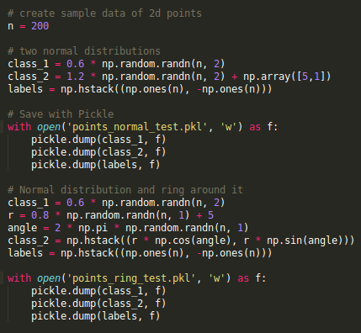

We assign the class 1 to the first half of points, and -1 to the second class of points.

Note: the zip function will fuse two or more lists together. If you zip three lists of 20 els each, the resulting list will have 20 elements, each being a tuple of three els.

In the end the algorithm is able to trace a decision boundary, using the whole training set.

Dense SIFT as image feature

Note: meshgrid takes two np arrays as parameters and returns a matrix of coordinates by stacking these two arrays together. The two resulting arrays have the same shape which is why it's useful for creating coordinate arrays
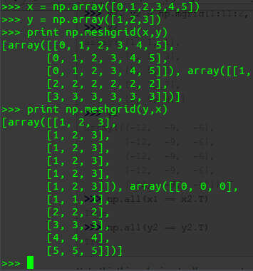

SIFT, again, is patented. So for any commercial use, you need to pay them a fee. Here are some (free) alternatives:
Both SIFT and SURF authors require license fees for usage of their original algorithms. it goes around 20.000 USD/year and the royalty fee is about 5%
(top kek)
o
p

k
e
k )
(Someone has)... done some research about the situation and there are the possible alternatives:
Keypoint detector:
- Harris corner detector
- Harris-Laplace - scale-invariant version of Harris detector (an affine invariant version also exists, presented by Mikolajczyk and Schmidt, and I believe is also patent free).
- Multi-Scale Oriented Patches (MOPs) - athough it is patented, the detector is basically the multi-scale Harris, so there would be no problems with that
- LoG filter - since the patented SIFT uses DoG (Difference of Gaussian) approximation of LoG (Laplacian of Gaussian) to localize interest points in scale, LoG alone can be used in modified, patent-free algorithm, tough the implementation could run a little slower
- FAST
- BRISK (includes a descriptor)
- ORB (includes a descriptor)
- KAZE - free to use, M-SURF descriptor (modified for KAZE's nonlinear scale space), outperforms both SIFT and SURF
- A-KAZE - accelerated version of KAZE, free to use, M-LDB descriptor (modified fast binary descriptor)
Keypoint descriptor:
- Normalized gradient - simple, working solution
- Wavelet filtered image patch - similar to gradient, the details are given in MOPs paper, but can be implemented differently to avoid the patent issue (e.g. using different wavelet basis or different indexing scheme)
- Histogram of oriented gradients
- GLOH
- LESH
- BRISK
- ORB
- FREAK
- LDB
Note that if you assign orientation to the interest point and rotate the image patch accordingly, you get rotational invariance for free. Even Harris corners are rotationally invariant and the descriptor may be made so as well.
Some more complete solution is done in Hugin, because they also struggled to have a patent-free interest point detector.

Note: SIFT can sometimes hang because stdout is asking for a password, so instead of using sudo in the code use the subprocess module

Naive Bayes Classifier

The assumption is that all features are independent and unrelated to each other (this is the 'naive') part. This type of classifier can be trained very efficiently, since the model chosen is applied to each feature independently.

Once a model is learned, unlike k nearest neighbors, there is no need to store the training data.

Support Vector machines

In its simplest form svm finds a hyperplane that cuts the training data into two categories. The function for such a hyperplane is

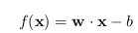

the weights are a linear combination of the support vectors with the lagrangian coefficients, so
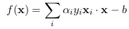

Here the X are in fact the mapped vector x through the K kernel function

svmutil is a potent library for svms (install: sudo aptitude install python-libsvm) and seems to have better results on multiclass classification than sklearn

OCR: Sudoku recognition

First we need to decide how to compute features vectors. Here we will return a feature vector of the flattened grayscale values
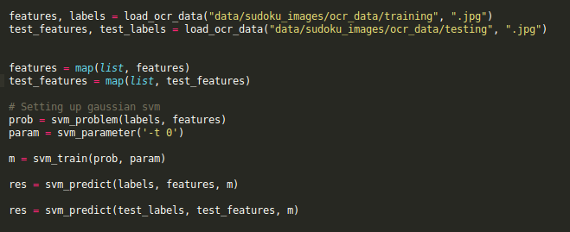
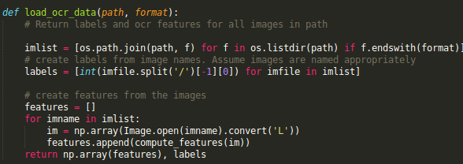
Then we use svm to train the model (libsvm)

Extracting cells from a complete sudoku image and recognizing characters
The next step is to automatically crop the cells from a complete image of sudoku and classify them
To achieve that, we are going to dim the image by applying a threshold to the grayscale values and sum the values of the rows and columns (apply the function twice, once per axis); then compute the center of mass of the strongest lines (x)
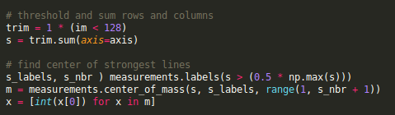

Then, provided we have the labels at our disposal (what numbers are already filled in, in a separate txt file), we can recognize where the numbers are written
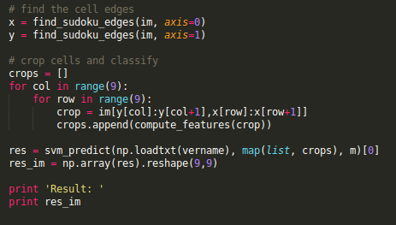
As we can see, the features are in fact features of the crops

